1. **ReactJS HOL**

**CohortDetails.js**

import React from "react";

import styles from "./CohortDetails.module.css";

function CohortDetails({ cohort }) {

const statusColor = cohort.status === "Ongoing" ? "green" : "blue";

return (

<div className={styles.box}>

<h3 style={{ color: statusColor }}>{cohort.title}</h3>

<dl>

<dt>Started On</dt>

<dd>{cohort.startDate}</dd>

<dt>Current Status</dt>

<dd>{cohort.status}</dd>

<dt>Coach</dt>

<dd>{cohort.coach}</dd>

<dt>Trainer</dt>

<dd>{cohort.trainer}</dd>

</dl>

</div>

);

}

export default CohortDetails;

**CohortDetails.module.css**

.box {

width: 300px;

display: inline-block;

margin: 10px;

padding: 10px 20px;

border: 1px solid black;

border-radius: 10px;

}

dt {

font-weight: 500;

}

**Cohort.js**

const cohorts = [

{

title: "INTADMDJF10 - .NET FSD",

startDate: "22-Feb-2022",

status: "Scheduled",

coach: "Aathma",

trainer: "Jojo Jose",

},

{

title: "ADM21JF014 - Java FSD",

startDate: "10-Sep-2021",

status: "Ongoing",

coach: "Apoorv",

trainer: "Elisa Smith",

},

{

title: "CDBJF21025 - Java FSD",

startDate: "24-Oct-2021",

status: "Ongoing",

coach: "Aathma",

trainer: "John Doe",

},

];

export default cohorts;

**App.js**

import React from "react";

import CohortDetails from "./CohortDetails";

import cohorts from "./Cohort";

function App() {

return (

<div style={{ padding: "20px" }}>

<h2>Cohorts Dashboard</h2>

{cohorts.map((cohort, index) => (

<CohortDetails key={index} cohort={cohort} />

))}

</div>

);

}

export default App;

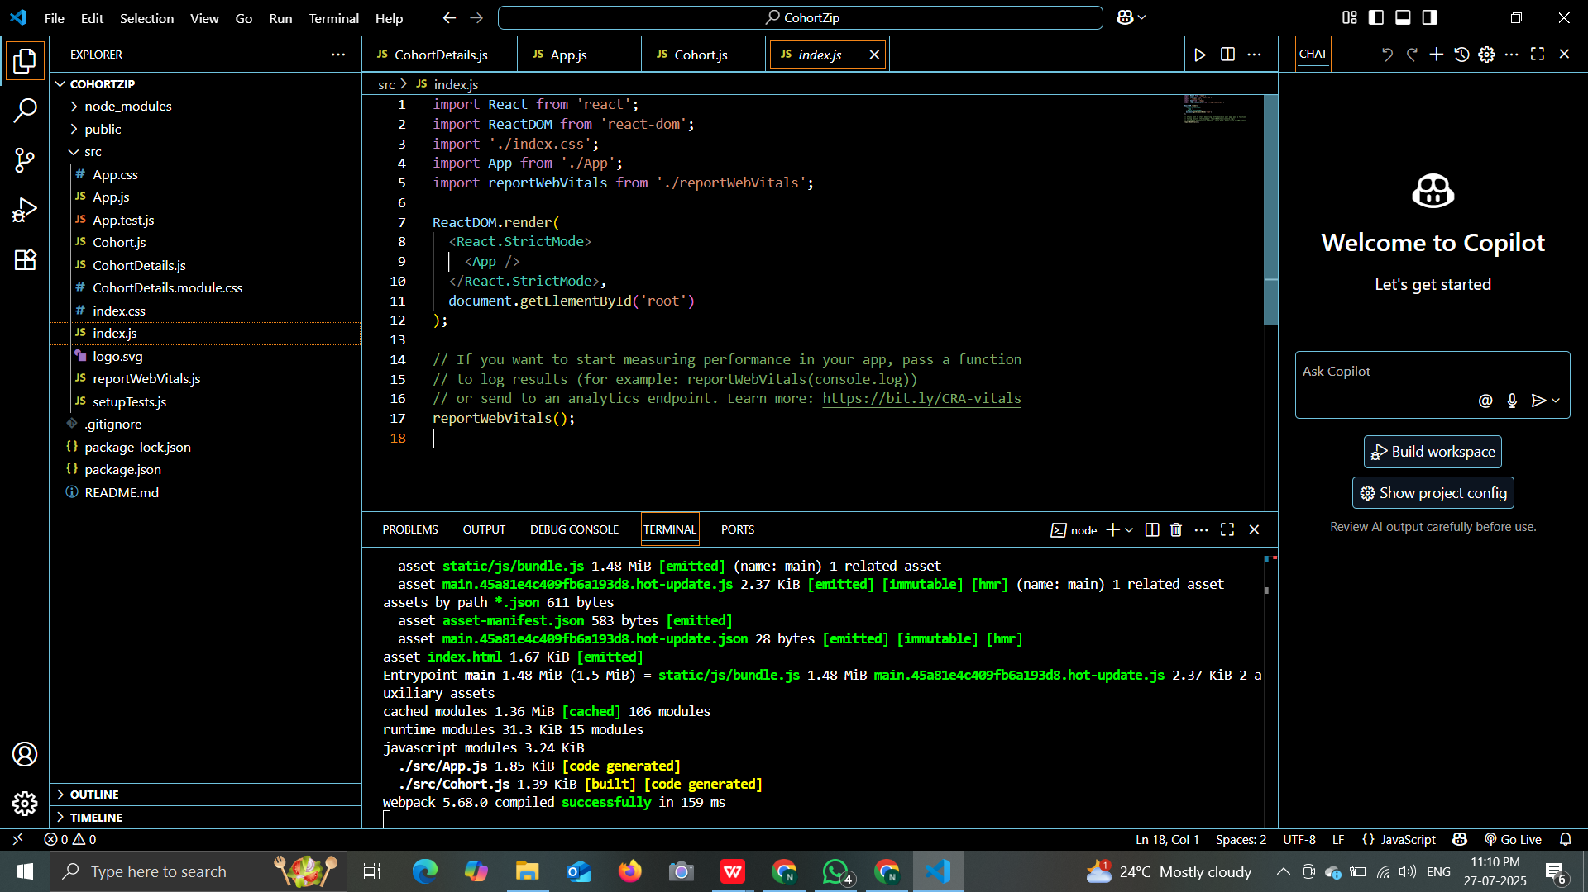

**OUTPUT:**

